Pet Adoption

Daniel Pivonka, Brianne Bindas, and Scott Mello

# 1. Goal

* Connect users to a database of over 300,000 pets up for adoption
* Use our search feature to find your perfect pet
* View pet profiles and pictures
* Add pets to your favorites so you don’t lose track of the pet you want
* Help more pets get adopted!

# 2. Features

* Pet Search Functionality
* Display list of pets that match search
* View pet profile and pictures
* Favorites database to store pets your thinking of adopting

# 3. Project Design

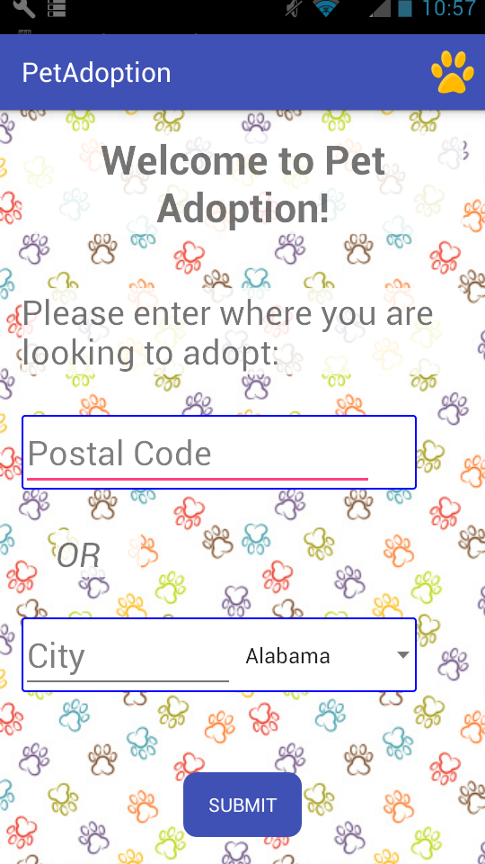

# 

# 4. File Structure

* MainActivity – Gets location from user – Code by Daniel, Layout by Brianne
* PetTypeActivity – Gets search options from user – Code by Daniel and Brianne, Layout by Brianne
* PetListActivity – Show list of pet returned from search, starts AsyncTask – Code by Daniel, Layout by Brianne
* PetViewActivity –Show profile and pictures of selected pet – Code By Daniel and Brianne, Layout by Brianne
* FavoritesActivity – Show list of pets added to favorites – Code by Scott, Layout by Scott and Brianne
* FavoritesViewActivity- Shows profile and picture of pet from favorites list – Code by Scott, Layout by Brianne
* Pets – Class to hold a single pets info – Code by Daniel
* PetAdapter – Adapter used to display pet list – Code by Daniel
* FavoritesTable – Database to hold favorite pets info – Code by Scott
* FavoritesContentProvider - - Code by Scott
* PetAdoptionDatabaseHelper - - Code by Scott
* PetCursorAdaptor - - Code by Scott
* Utils – Network utilities to retrieve pets from API – Code by Daniel